**The Frequency Spectrum and Applications**

**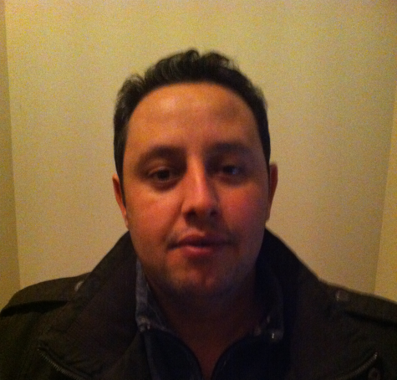**

**ID:201224180103**

**Name: BENNECER BACHIR**

**School of Resources and Environment**

**UESTC 2013/2014**

**Introduction:**

Any signal that can be represented as amplitude that varies with time has a corresponding frequency spectrum. This includes familiar concepts such as [visible light](http://en.wikipedia.org/wiki/Visible_light) ([color](http://en.wikipedia.org/wiki/Color)), musical notes, radio, and even the regular rotation of the earth. When these physical phenomena are represented in the form of a frequency spectrum, certain physical descriptions of their internal processes become much simpler. Often, the frequency spectrum clearly shows [harmonics](http://en.wikipedia.org/wiki/Harmonics), visible as distinct spikes or lines at particular frequencies that provide insight into the mechanisms that generate the entire signal.

**Frequency spectrum:**

The frequency spectrum of a [time-domain](http://en.wikipedia.org/wiki/Time_domain) [signal](http://en.wikipedia.org/wiki/Signal_(electronics)) is a representation of that signal in the [frequency domain](http://en.wikipedia.org/wiki/Frequency_domain). The frequency spectrum can be generated via a [Fourier transform](http://en.wikipedia.org/wiki/Fourier_transform) of the signal, and the resulting values are usually presented as [amplitude](http://en.wikipedia.org/wiki/Amplitude) and [phase](http://en.wikipedia.org/wiki/Phase_(waves)), both plotted versus [frequency](http://en.wikipedia.org/wiki/Frequency).

**Frequency domain vs Time domain**:

**Time domain:**

Time domain is the analysis of mathematical [functions](http://en.wikipedia.org/wiki/Function_(mathematics)), physical [signals](http://en.wikipedia.org/wiki/Signal_(information_theory)) or [time series](http://en.wikipedia.org/wiki/Time_series) of [economic](http://en.wikipedia.org/wiki/Economics) or [environmental](http://en.wikipedia.org/wiki/Environmental_statistics) data, with respect to [time](http://en.wikipedia.org/wiki/Time). In the time domain, the signal or function's value is known for all [real numbers](http://en.wikipedia.org/wiki/Real_number), for the case of [continuous time](http://en.wikipedia.org/wiki/Continuous_time), or at various separate instants in the case of [discrete time](http://en.wikipedia.org/wiki/Discrete_time). An [oscilloscope](http://en.wikipedia.org/wiki/Oscilloscope) is a tool commonly used to visualize real-world signals in the time domain. A [time-domain](http://en.wikipedia.org/wiki/Time-domain) graph shows how a signal changes over time. Whereas a frequency-domain graph shows how much of the signal lies within each given frequency band over a range of frequencies.

**Frequency domain:**

In [electronics](http://en.wikipedia.org/wiki/Electronics), [control systems engineering](http://en.wikipedia.org/wiki/Control_systems_engineering), and [statistics](http://en.wikipedia.org/wiki/Statistics), the **frequency domain** refers to the analysis of [mathematical functions](http://en.wikipedia.org/wiki/Mathematical_function) or [signals](http://en.wikipedia.org/wiki/Signal_(information_theory)) with respect to [frequency](http://en.wikipedia.org/wiki/Frequency), rather than time. Put simply. A frequency-domain representation can also include information on the [phase](http://en.wikipedia.org/wiki/Phase_(waves)) shift that must be applied to each [sinusoid](http://en.wikipedia.org/wiki/Sine_wave) in order to be able to recombine the frequency components to recover the original time signal.

A given function or signal can be converted between the time and frequency domains with a pair of mathematical [operators](http://en.wikipedia.org/wiki/Operator_(mathematics)) called a [transform](http://en.wikipedia.org/wiki/Transform_(mathematics)). An example is the [Fourier transform](http://en.wikipedia.org/wiki/Fourier_transform), which decomposes a function into the sum of a (potentially infinite) number of [sine wave](http://en.wikipedia.org/wiki/Sine_wave) frequency components. The 'spectrum' of frequency components is the frequency domain representation of the signal. The [inverse Fourier transform](http://en.wikipedia.org/wiki/Inverse_Fourier_transform) converts the frequency domain function back to a time function.

Signal processing also allows representations or transforms that result in a joint [time-frequency domain](http://en.wikipedia.org/wiki/Time-frequency_representation), with the [instantaneous frequency](http://en.wikipedia.org/wiki/Instantaneous_frequency) being a key link between the time domain and the frequency domain.

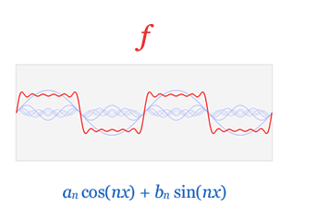

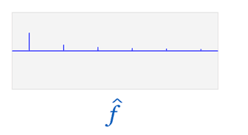

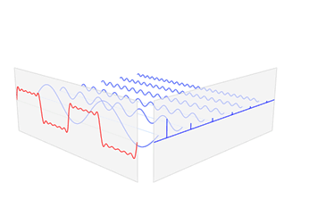

Figure1: illustration of time domain and frequency domain.

Figure1 shows a visualization of the relationship between the time domain and the frequency domain of a function, based on its Fourier transform. The Fourier transform takes an input function f (in red) in the "time domain" and converts it into a new function f-hat (in blue) in the "frequency domain".

In other words, the original function can be thought of as being "amplitude given time", and the Fourier transform of the function is "amplitude given frequency".

Shown here, a simple 6-component approximation of the square wave is decomposed (exactly, for simplicity) into 6 sine waves. These component frequencies show as very sharp peaks in the frequency domain of the function, shown as the blue graph.

**Frequency spectrum in life:**

**Light:** from many different sources contains various colors, each with its own brightness or intensity. A rainbow, or [prism](http://en.wikipedia.org/wiki/Prism_(optics)), sends these component colors in different directions, making them individually visible at different angles. A graph of the intensity plotted against the frequency (showing the brightness of each color) is the **frequency spectrum** of the light. When all the visible frequencies are present equally, the perceived color of the light is white, and the spectrum is a flat line. Therefore, flat-line spectrums in general are often referred to as *white*, whether they represent light or another type of wave phenomenon (sound, for example, or vibration in a structure).

**Sound**: similarly, a source of sound can have many different frequencies mixed. A [musical tone's](http://en.wikipedia.org/wiki/Musical_tone) [timbre](http://en.wikipedia.org/wiki/Timbre) is characterized by its [harmonic spectrum](http://en.wikipedia.org/wiki/Harmonic_spectrum). Sound in our environment that we refer to as *noise* includes many different frequencies. When a sound signal contains a mixture of all audible frequencies, distributed equally over the audio spectrum, it is called [white noise](http://en.wikipedia.org/wiki/White_noise).

**Frequency spectrum and spectrum analysis:**

Spectrum analysis, also referred to as [frequency domain analysis](http://en.wikipedia.org/wiki/Frequency_domain) or [spectral density estimation](http://en.wikipedia.org/wiki/Spectral_density_estimation), is the technical process of decomposing a complex signal into simpler parts. As described above, many physical processes are best described as a sum of many individual frequency components. Any process that quantifies the various amounts (e.g. amplitudes, powers, intensities, or phases), versus frequency can be called spectrum analysis.

Spectrum analysis can be performed on the entire signal. Alternatively, a signal can be broken into short segments (sometimes called *frames*), and spectrum analysis may be applied to these individual segments. [Periodic functions](http://en.wikipedia.org/wiki/Periodic_function) (such as sin(t)) are particularly well-suited for this sub-division. General mathematical techniques for analyzing non-periodic functions fall into the category of [Fourier analysis](http://en.wikipedia.org/wiki/Fourier_analysis).

The [Fourier transform](http://en.wikipedia.org/wiki/Fourier_transform) of a function produces a frequency spectrum which contains all of the information about the original signal, but in a different form. This means that the original function can be completely reconstructed (*synthesized*) by an [inverse Fourier transform](http://en.wikipedia.org/wiki/Inverse_Fourier_transform). For perfect reconstruction, the spectrum analyzer must preserve both the [amplitude](http://en.wikipedia.org/wiki/Amplitude) and [phase](http://en.wikipedia.org/wiki/Phase_(waves)) of each frequency component. These two pieces of information can be represented as a 2-dimensional vector, as a complex number, or as magnitude (amplitude) and phase in [polar coordinates](http://en.wikipedia.org/wiki/Polar_coordinates). A common technique in signal processing is to consider the squared amplitude, or [power](http://en.wikipedia.org/wiki/Power_(physics)); in this case the resulting plot is referred to as a [power spectrum](http://en.wikipedia.org/wiki/Power_spectrum).

Because of reversibility, the Fourier transform is called a *representation* of the function, in terms of frequency instead of time; thus, it is a [frequency domain](http://en.wikipedia.org/wiki/Frequency_domain) representation. Linear operations that could be performed in the time domain have counterparts that can often be performed more easily in the frequency domain. Frequency analysis also simplifies the understanding and interpretation of the effects of various time-domain operations, both linear and non-linear. For instance, only [non-linear](http://en.wikipedia.org/wiki/Nonlinearity) or [time-variant](http://en.wikipedia.org/wiki/Time-variant_system) operations can create new frequencies in the frequency spectrum.

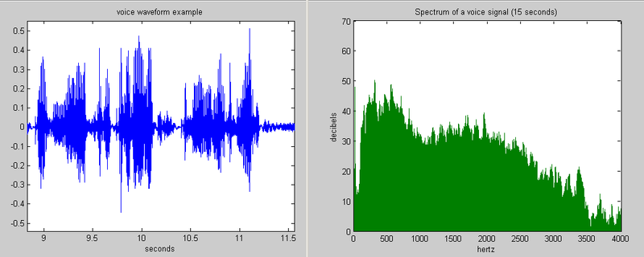

Figure2: Example of a voice waveform and its frequency spectrum

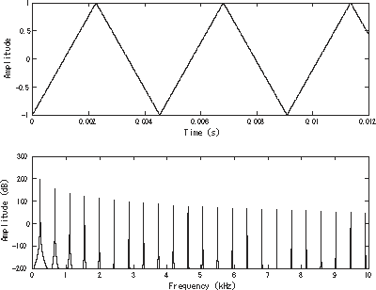

Figure3: a [triangle wave](http://en.wikipedia.org/wiki/Triangle_wave) pictured in the time domain (top) and frequency domain (bottom).

**Applications of signal spectrum:**

In practice, nearly all software and electronic devices that generate frequency spectrum apply a [fast Fourier transform](http://en.wikipedia.org/wiki/Fast_Fourier_transform) (FFT), which is a specific mathematical approximation to the full integral solution. Formally stated, the FFT is a method for computing the [discrete Fourier transform](http://en.wikipedia.org/wiki/Discrete_Fourier_transform) of a [sampled signal](http://en.wikipedia.org/wiki/Sampling_(signal_processing)).

### Computer engineering application: Data compression

The field of digital signal processing relies heavily on operations in the frequency domain (i.e. on the Fourier transform). For example, several lossy image and sound compression methods employ the discrete Fourier transform: the signal is cut into short segments, each is transformed, and then the Fourier coefficients of high frequencies, which are assumed to be unnoticeable, are discarded. The decompressor computes the inverse transform based on this reduced number of Fourier coefficients. (Compression applications often use a specialized form of the DFT, the [discrete cosine transform](http://en.wikipedia.org/wiki/Discrete_cosine_transform) or sometimes the [modified discrete cosine transform](http://en.wikipedia.org/wiki/Modified_discrete_cosine_transform).) Some relatively recent compression algorithms, however, use [wavelet transforms](http://en.wikipedia.org/wiki/Wavelet_transform), which give a more uniform compromise between time and frequency domain than obtained by chopping data into segments and transforming each segment. In the case of [JPEG2000](http://en.wikipedia.org/wiki/JPEG2000), this avoids the spurious image features that appear when images are highly compressed with the original [JPEG](http://en.wikipedia.org/wiki/JPEG).

### Spectral analysis

When the DFT is used for [spectral analysis](http://en.wikipedia.org/wiki/Frequency_spectrum#Spectrum_analysis), the \{x_n\}\, sequence usually represents a finite set of uniformly spaced time-samples of some signals x(t)\,, where *t* represents time. The conversion from continuous time to samples (discrete-time) changes the underlying [Fourier transform](http://en.wikipedia.org/wiki/Continuous_Fourier_transform) of x(t) into a [discrete-time Fourier transform](http://en.wikipedia.org/wiki/Discrete-time_Fourier_transform) (DTFT), which generally entails a type of distortion called [aliasing](http://en.wikipedia.org/wiki/Aliasing). Choice of an appropriate sample-rate is the key to minimizing that distortion. Similarly, the conversion from a very long (or infinite) sequence to a manageable size entails a type of distortion called [*leakage*](http://en.wikipedia.org/wiki/Spectral_leakage), which is manifested as a loss of detail (aka resolution) in the DTFT. Choice of an appropriate sub-sequence length is the primary key to minimizing that effect. When the available data (and time to process it) is more than the amount needed to attain the desired frequency resolution, a standard technique is to perform multiple DFTs, for example to create a [spectrogram](http://en.wikipedia.org/wiki/Spectrogram). If the desired result is a power spectrum and noise or randomness is present in the data, averaging the magnitude components of the multiple DFTs is a useful procedure to reduce the [variance](http://en.wikipedia.org/wiki/Variance) of the spectrum (also called a [periodogram](http://en.wikipedia.org/wiki/Periodogram) in this context); two examples of such techniques are the [Welch method](http://en.wikipedia.org/wiki/Welch_method) and the [Bartlett method](http://en.wikipedia.org/wiki/Bartlett_method); the general subject of estimating the power spectrum of a noisy signal is called [spectral estimation](http://en.wikipedia.org/wiki/Spectral_estimation).

A final source of distortion (or perhaps *illusion*) is the DFT itself, because it is just a discrete sampling of the DTFT, which is a function of a continuous frequency domain. That can be mitigated by increasing the resolution of the DFT. That procedure is illustrated at [sampling the DTFT](http://en.wikipedia.org/wiki/Discrete-time_Fourier_transform#Sampling_the_DTFT).

* The procedure is sometimes referred to as *zero-padding*, which is a particular implementation used in conjunction with the [fast Fourier transform](http://en.wikipedia.org/wiki/Fast_Fourier_transform) (FFT) algorithm. The inefficiency of performing multiplications and additions with zero-valued "samples" is more than offset by the inherent efficiency of the FFT.
* As already noted, leakage imposes a limit on the inherent resolution of the DTFT. So there is a practical limit to the benefit that can be obtained from a fine-grained DFT.

### Partial differential equations

Discrete Fourier transforms are often used to solve [partial differential equations](http://en.wikipedia.org/wiki/Partial_differential_equations), where again the DFT is used as an approximation for the [Fourier series](http://en.wikipedia.org/wiki/Fourier_series) (which is recovered in the limit of infinite *N*). The advantage of this approach is that it expands the signal in complex exponentials *einx*, which are Eigen functions of differentiation: *d*/*dx* *einx* = *in* *einx*. Thus, in the Fourier representation, differentiation is simple. We just multiply by *in*. (Note, however, that the choice of *n* is not unique due to aliasing; for the method to be convergent, a choice similar to that in the [trigonometric interpolation](http://en.wikipedia.org/wiki/Discrete_Fourier_transform#Trigonometric_interpolation_polynomial) section should be used.) A [linear differential equation](http://en.wikipedia.org/wiki/Linear_differential_equation) with constant coefficients is transformed into an easily solvable algebraic equation. One then uses the inverse DFT to transform the result back into the ordinary spatial representation. Such an approach is called a [spectral method](http://en.wikipedia.org/wiki/Spectral_method).

**Conclusion**

Frequency spectrum is a tool of utmost importance in signal processing applications. Frequency spectrum is widely used in such areas as communications, geology, remote sensing, and image processing. While time-domain analysis shows how a signal changes over time, frequency-domain analysis shows how the signal's energy is distributed over a range of frequencies. A frequency-domain representation also includes information on the phase shift that must be applied to each frequency component in order to recover the original time signal with a combination of all the individual frequency components.